SPRING 2023 - HONORS 370-02 (3 cr.) - Tu/Th 1:30-2:45 PM
“Crossing Paths Between the Public and the Private”
If you have questions, please contact Vilma Navarro-Daniels (navarrod@wsu.edu)

Learn about the complexities of social, cultural, and political changes experienced by a variety of countries.
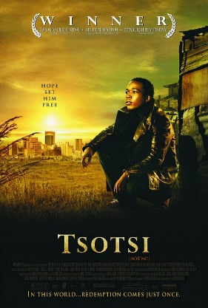
Meet a bundle of characters of diverse age, nationality, language, religious believes, gender, race, social class, culture, and ideology.
Learn about the interaction between the social and the individual, the public and the domestic realm, the historical and the transcendental.

